**Assignment no 6**

Q.1 **Program to find greatest among two 8-bit numbers.**

**Statement:**

Input numbers from memory location 2050H and 2051h and store greatest number in memory locatiomn 2055h

**Program**

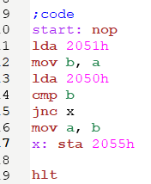

**Output:**

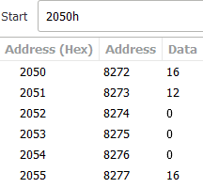

**Register:**

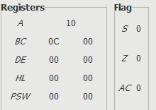

**Q.2 Program to find smallest among two 8-bit numbers.**

**Statement:**

Input numbers from memory location 2050H and 2051H and store smallest number in memory location 2055H.

**Program:**

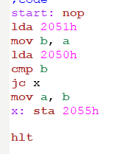

**Output:**

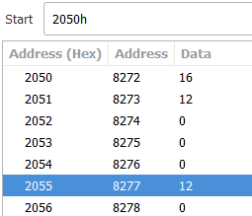

**Register:**

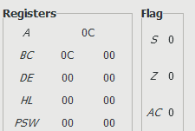

**Q.3 Program to find whether a number is odd or even.**

**Statement:**

Input number from memory location 2050H and store result in 2055H.

**Program:**

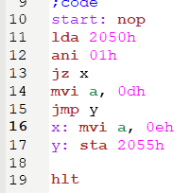

**Output:**

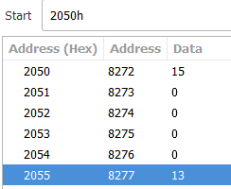

**Registers:**

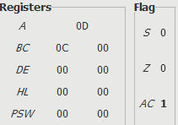

**Q.4 Program to count no. of 1’s in given number.**

**Statement:**

Input number from memory location 2050H and store result in 2055H.

**Program:**

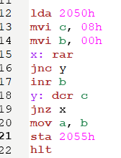

**Output:**

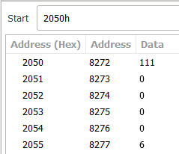

**Registers:**

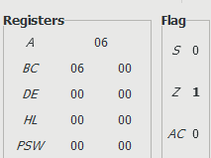

**Q.5 Display number from 1 to 10.**

**Statement:**

NULL

**Program.**

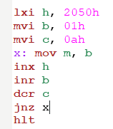

**Output:**

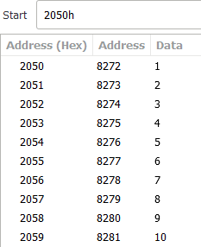

**Registers:**

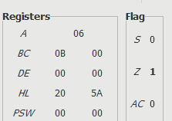

**Q.6 Find the sum of numbers from 1 to 10.**

**Statement:**

NULL

**Program:**

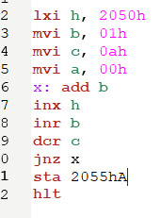

**Output:**

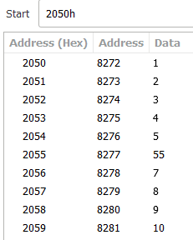

**Registers:**

